General Chemistry 2 | 3rd Quarter
WW5: Standard Enthalpy Formation & Hess’ Law
January 20 2021
Page

- Calculate the heat combustion at constant pressure of liquid ethanol.

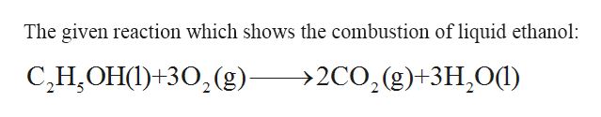

ΔH_{f}° [Reactants]:
C₂H₅OH _{(l)} = -277.69 kJ/mol
O₂ _{(g)} = 0 kJ/mol

ΔH_{f}° [Products]:
CO₂ _{(g)} = -393.509 kJ/mol
H₂O _{(l)} = -285.83 kJ/mol

ΔH°_{rxn} = ΣnH°_{f} [Products] – ΣnH°_{f} [Reactants]
ΔH°_{rxn} = [2(-393.509) + 3(-285.83)] - [-277.69 + 3(0)]
ΔH°_{rxn} = [-787.018 + -857.49] - [-277.69]
ΔH°_{rxn} = (-1644.98) - (-277.69)
ΔH°_{rxn} = -1367.29

